* Trained on 2000 turn timeout for 1million games
  + 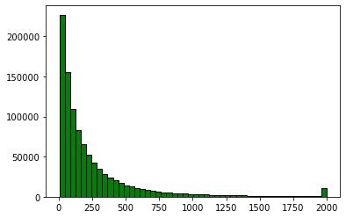
  + 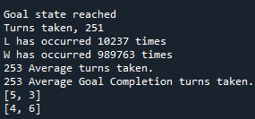
* Test on 50 turn timeout for 10k games
  + 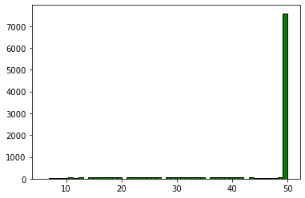
  + 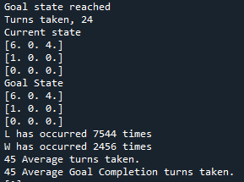
* Test on 100 turn timeout for 10k games
  + 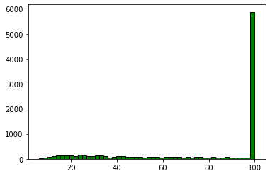
  + 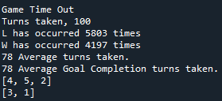
* Test on 200 turn timeout for 10k games
  + 
   